19 мая в аудитории 121а в 16:20 состоится увлекательная лекция доктора химических наук из Великобритании, и его коллеги из Москвы на английском языке!
Она будет посвящена различным применениям органических полимеров. Описание можете прочитать ниже:
“Polymers as ligands for quantum dots, metal cluster complexes, for intercellular functional protein delivery and for controlling mesocrystal formation”
 | Dr Boytsova started working at Chemical Engineering and Applied Chemistry of Aston University as a Marie Curie Fellow in October 2015 after a successful grant application. The project she is developing new class of inorganic materials to explore their application in materials for environment and energy as well as for biological sciences. Dr Boytsova received multidisciplinary training from leading scientists in both academia and industry in the field of inorganic chemistry, solid state and in the synthesis of different materials (nanoparticles, powders, films etc).
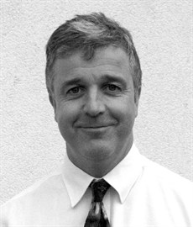 | Dr Sutherland is a Reader in Organic and Polymer Chemistry in the department of Chemical Engineering & Applied Chemistry at Aston University, UK. He trained as a synthetic organic chemist (BSc & PhD, Manchester University, UK; PDRA, MIT, USA). This background in synthesis enables him to develop new polymer-based materials with ‘designer’ properties such as the ability to bind nanoparticles; emit light; enter living cells etc.

This lecture will be divided into two parts. In part one an approach to generate functionalised insoluble polymer beads will be given. These materials may be used as ‘polymeric ligands’ for binding inorganic entities such as quantum dots and octahedral metal complexes. The resultant inorganic-organic hybrid structures have been utilised to delivery functional proteins into cells. In part 2, the use of soluble polymers, such as PEG and BRIJ, to template mesocrystal formation will be outlined. A full description of the characterisation of these fascinating mesocrystalline materials will be presented together with preliminary data relating to photoxidation - just one of the many potential applications of mesocrystals.

